- We expect the Bank of England's Monetary Policy Committee to cut Bank Rate by 25bps at next week's meeting. The committee remains divided on how quickly policy should be loosened, and the vote split is likely to reflect this. We suspect Swati Dhingra and Alan Taylor will vote for a larger cut, whereas Huw Pill and Catherine Mann will likely vote to keep Bank Rate unchanged.
- Recent data suggest labour market conditions are loosening only gradually in response to sluggish growth and April's increases in employers' national insurance contributions and the national minimum wage. This should reduce some of the urgency of the situation for the MPC's key swing voters, some of whom previously appeared close to supporting a faster pace of cuts.
- The MPC will likely revise up its near-term inflation forecast, due to upside surprises in the services category and higher energy and oil futures prices. But we expect the MPC will forecast inflation very close to its target two and three years out. This would send a message that the MPC expects to continue to loosen policy steadily over the rest of this year and into next.
The Bank of England's Monetary Policy Committee has voted to lower Bank Rate at alternate meetings since its rate-cutting cycle began last summer. After a pause at the June meeting, we think a 25bp cut in August is almost guaranteed. Financial markets agree, pricing in a 93% chance of a 25bp cut next week. From our perspective, the more important issue is the MPC's signalling about where we go from there.
The decision to keep Bank Rate unchanged at the June meeting was widely anticipated, but the 6-3 vote split and tone of the minutes were more dovish than expected, with most MPC members appearing to have greater conviction that slack was opening up in the jobs market. The main cause of this dovish tilt was concern around the pace at which labour market conditions were loosening in response to soft growth and April's increases in employers' national insurance contributions and the minimum wage. A 109,000 m/m fall in HMRC's measure of payrolled employees in May was the main trigger for these worries. However, that drop was later revised down to just 25k. And the first estimate for June reported a 41,000 fall, which was at the lower end of the range of provisional outturns for job losses seen in recent months. (Chart 1).
Chart 1: May's large fall in payrolled employees was revised much lower in the latest release
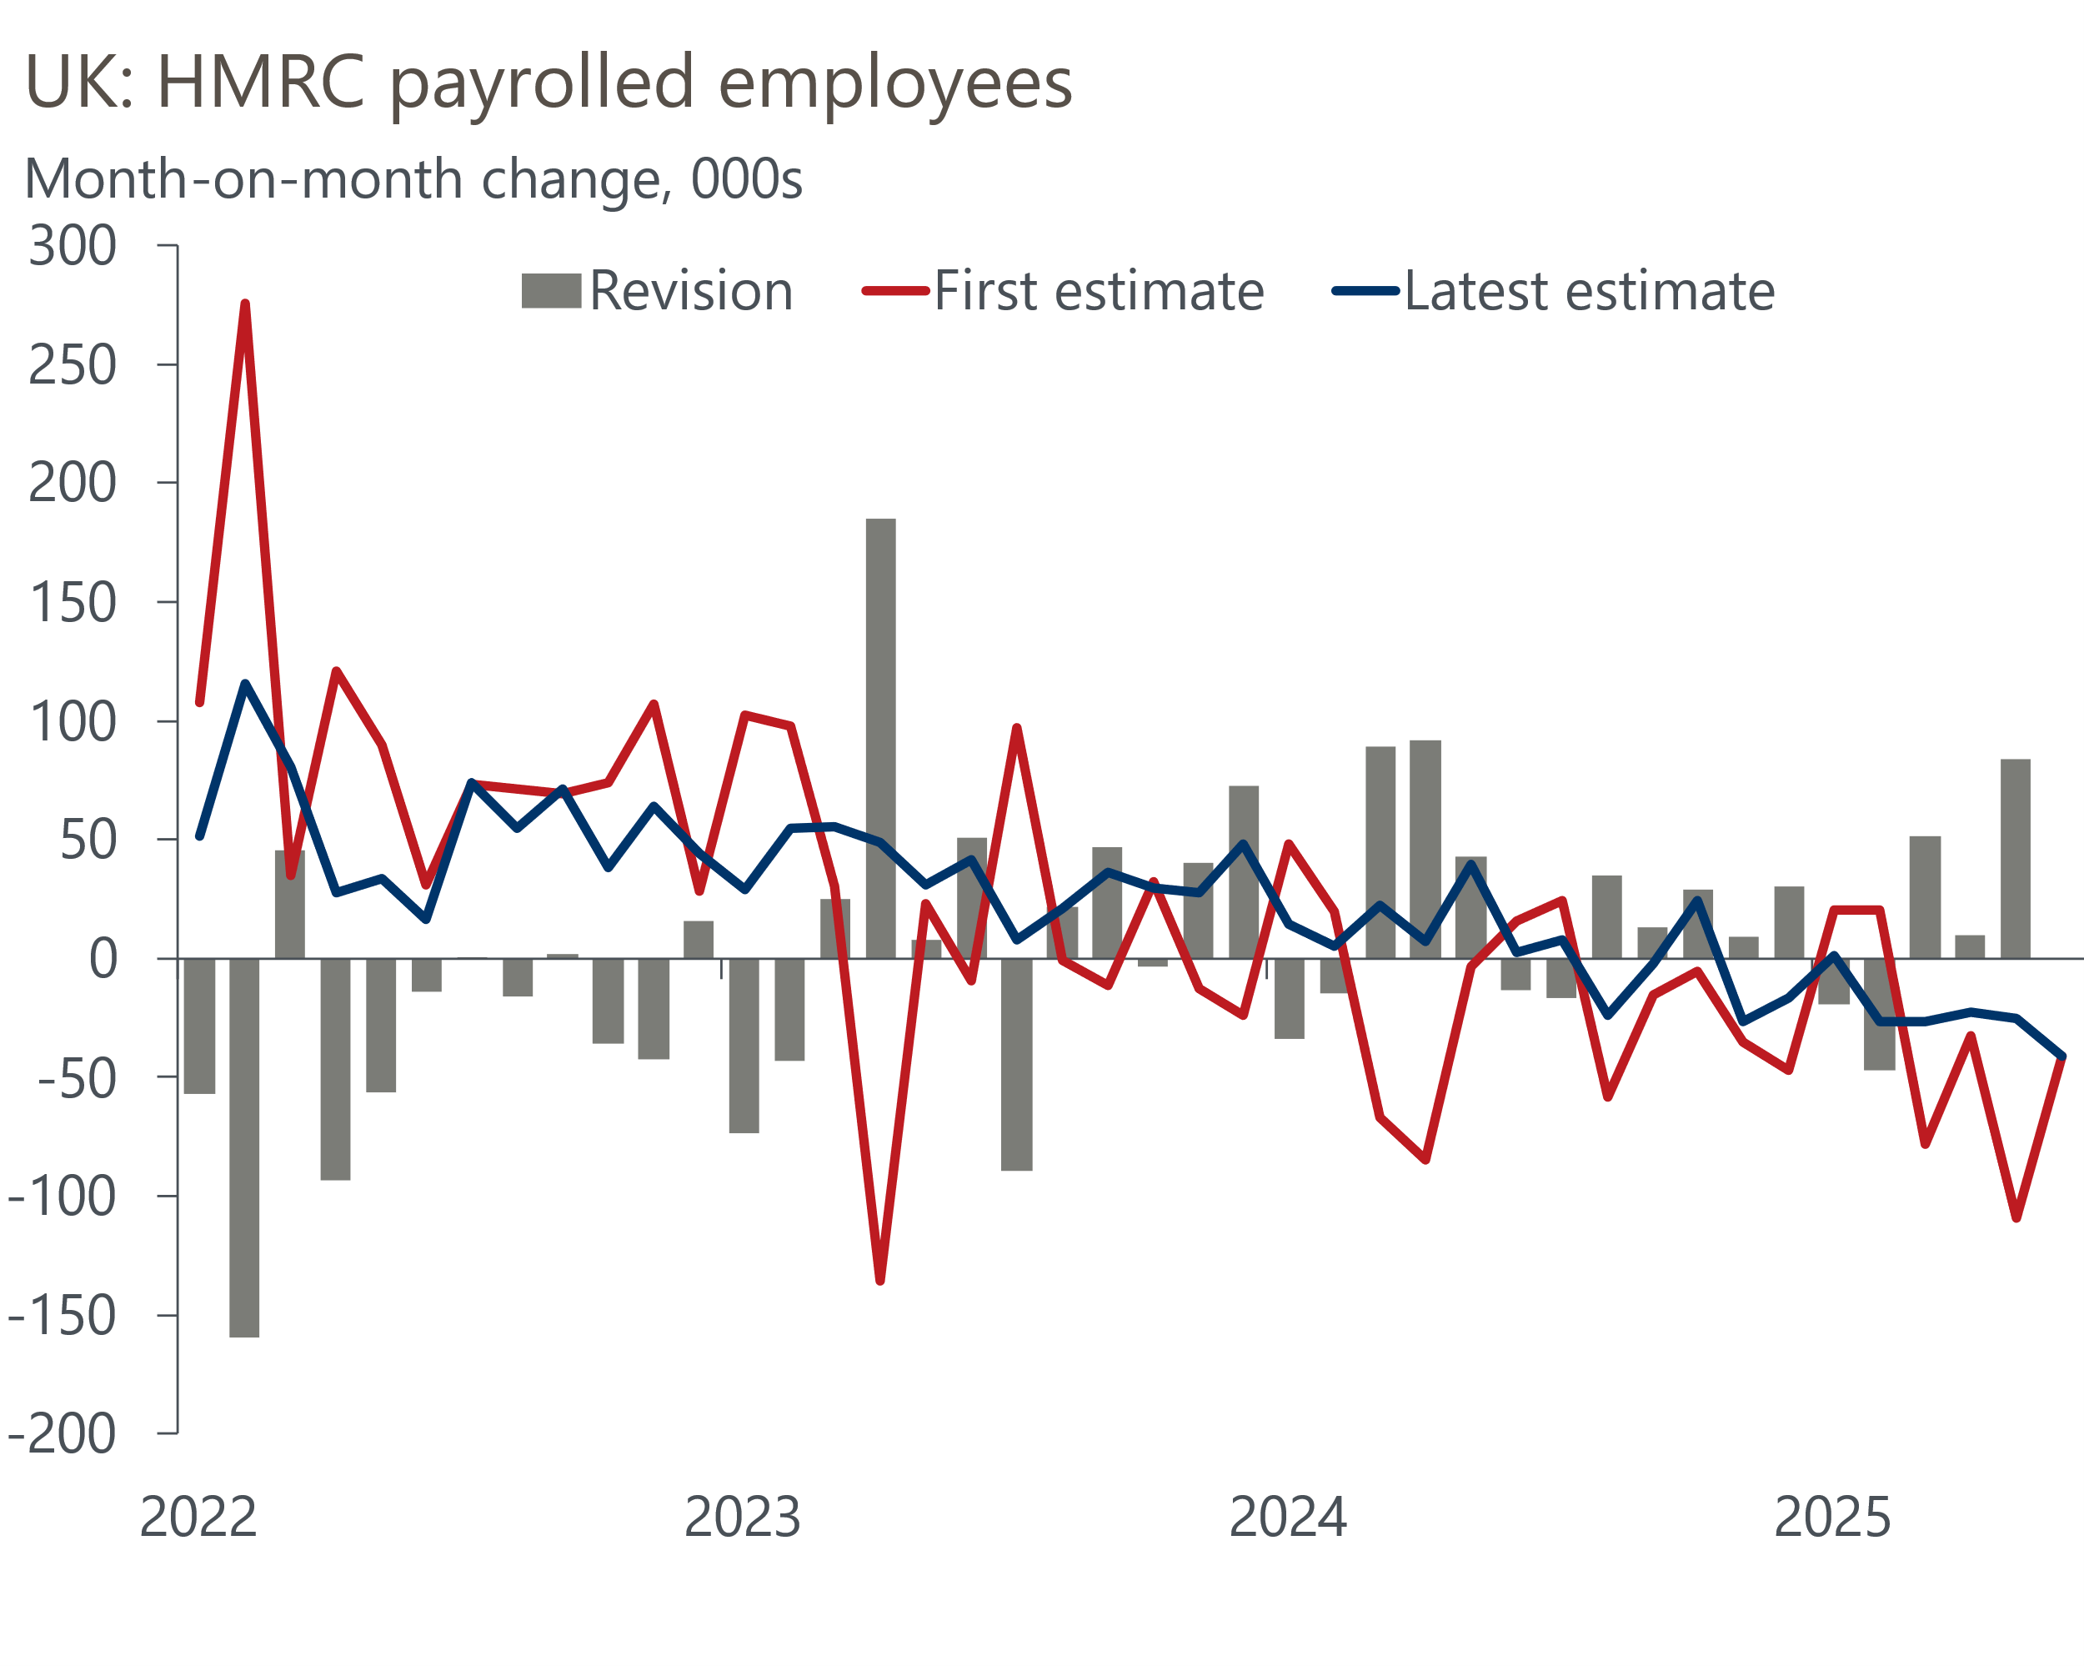
Source: Oxford Economics calculations using data from the Office for National Statistics

In June's minutes, the MPC flagged that recent experience suggested the revisions to early vintages of the HMRC data could be large, and that May's outturn was particularly uncertain. But given the messaging from the committee's key swing voters has been that a more aggressive approach to loosening policy would only be warranted if they saw slack opening up in the economy much more quickly, we suspect the very large upward revision to May's outturn somewhat reduces the urgency of the situation for these committee members.
Nevertheless, we expect the MPC to conclude that there's still plenty of evidence that labour market conditions are loosening. Indeed, the Office for National Statistics reported that vacancies fell further below their pre-pandemic level in the three months to June. Meanwhile, measures of employment growth from the BoE's Decision Maker Panel and the S&P Global PMI survey have continued to weaken.

Other data have provided mixed messages on the inflation outlook
There's been little news in data published since the June meeting. And beyond the interesting developments in the jobs data, what modest news we've had elsewhere has been somewhat ambiguous for the MPC. Pay growth has continued to cool. Private sector regular pay growth – the BoE's preferred measure – slipped below 5% in the three months to May and remains on track to undershoot the BoE's most recent staff forecast (Chart 2).
Chart 2: The MPC's favoured measures of inflation persistence have sent mixed signals
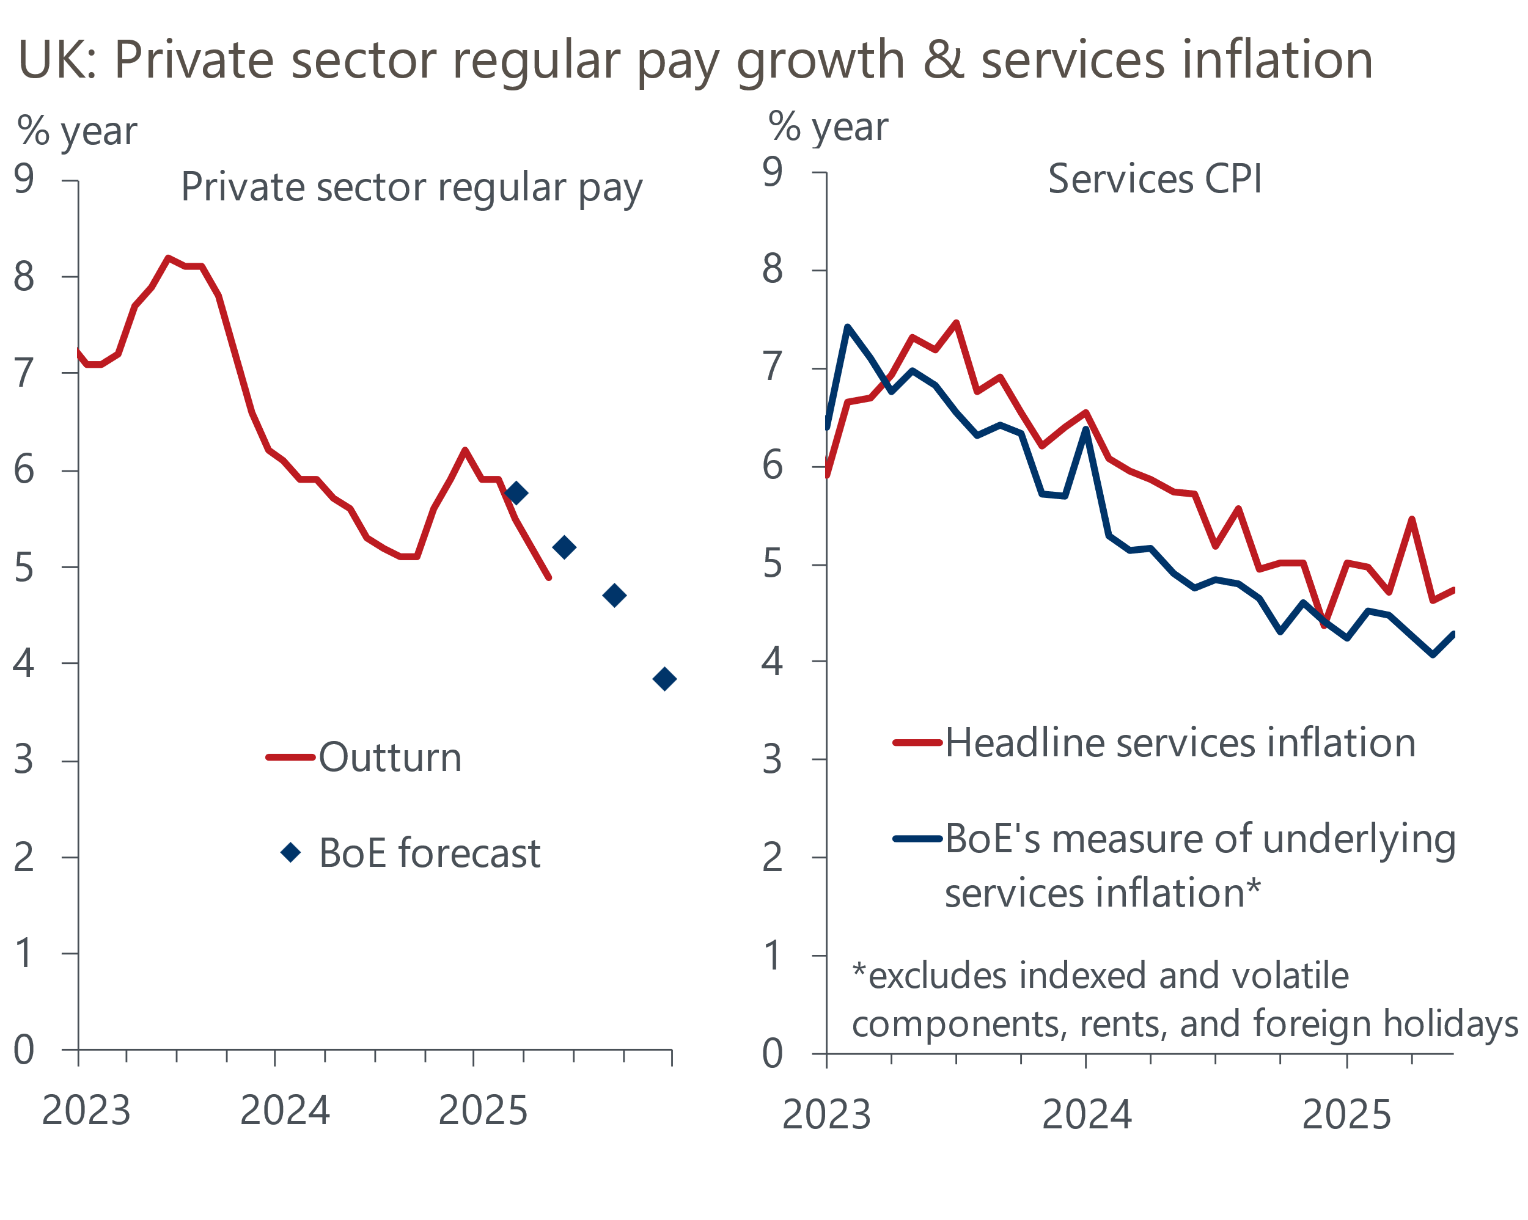
Source: Haver Analytics, Bank of England Monetary Policy Report
The key question for the MPC is whether this downward trajectory for pay growth will continue. On that front, the three-month-on-three-month annualised rate – a better guide to recent momentum in pay growth – dropped to 3.7% in the three months to May. This suggests that pay settlements are getting closer to the pace the MPC considers to be consistent with achieving the inflation target over the medium term. The latest outturns from the BoE's Decision Maker Panel survey's measure of wage expectations and recent comments from MPC members on the BoE Agents' annual pay survey have been consistent with this message.
But other data is likely to reinforce the concerns of some MPC members that recent evidence of disinflationary pressure is much clearer in the labour market than in domestic prices. CPI inflation rose 0.2ppts to 3.6% in June, which was slightly above what the BoE had expected. Although some of the upside surprise was due to movements in volatile categories, there was another strong reading for food prices, which the MPC had flagged in June's minutes as having the potential to lift inflation expectations and generate greater persistence in price-setting. Services inflation also came in a little higher than anticipated, and the steady downward trend in the BoE's preferred measure of underlying services inflation – which excludes some of the more volatile components – halted in June (Chart 2).

The MPC remains divided, but the majority will likely signal that the cut-hold tempo of loosening is still appropriate
Signs that the labour market is loosening only gradually, alongside mixed messages in other recent economic releases, paint a marginally more hawkish picture than was seen at the time of the June meeting. Given that public comments by MPC members since that meeting have been few and far between, and that the MPC's recent messaging has been very inconsistent, it's difficult to know how recent data have impacted the views of committee members.
We suspect that BoE Chief Economist Huw Pill and external member Catherine Mann will vote to keep Bank Rate at 4.25% at next week's meeting. Pill characterised his vote for no change in May as a skip rather than a signal that he wanted to stop loosening entirely. Given policy was ultimately loosened at that meeting, we wouldn't be surprised if either member voted for another hold at the August meeting.
At the other end of the spectrum, the three dissenters at the June meeting, Deputy Governor Dave Ramsden and external members Swati Dhingra and Alan Taylor, voted for a 25bp cut. Dhingra and Taylor have both long been more dovish than the rest of the committee, arguing that the weakness in demand risks inflation undershooting the BoE's 2% target in the medium term. With Taylor having recently doubled down on this message in a speech at the London School of Economics and emphasised that Bank Rate is still well above neutral, we think there's a good chance that Dhingra and Taylor will vote for a 50bp reduction next week.
We expect the remaining five committee members to vote for a 25bp cut at the August meeting, in line with the cut-hold tempo that has been established over the past year. Given it is probably still too early to judge how large the total impact of April's increases in employers' NICs and the national living wage will be, and global uncertainty remains elevated, the tone of the BoE's communications is likely to be relatively cautious. Beyond highlighting the committee's deep divisions, we think the minutes are likely to emphasise that the risks for inflation in the medium-term remain two-sided and that the MPC's "gradual and careful approach to the further withdrawal of monetary policy restraint remains appropriate".

The MPC will likely use its forecast to reinforce its gradualist message
The MPC will present its updated forecasts at the August meeting. The movement in market pricing since the previous set of projections was produced in May has been relatively limited. Current market expectations for Bank Rate are only 13bps higher than before the May Monetary Policy Report for the end of 2025. The difference further out is even smaller (Chart 3).
Chart 3: Markets have become slightly more hawkish on the near term since the MPC's last forecast
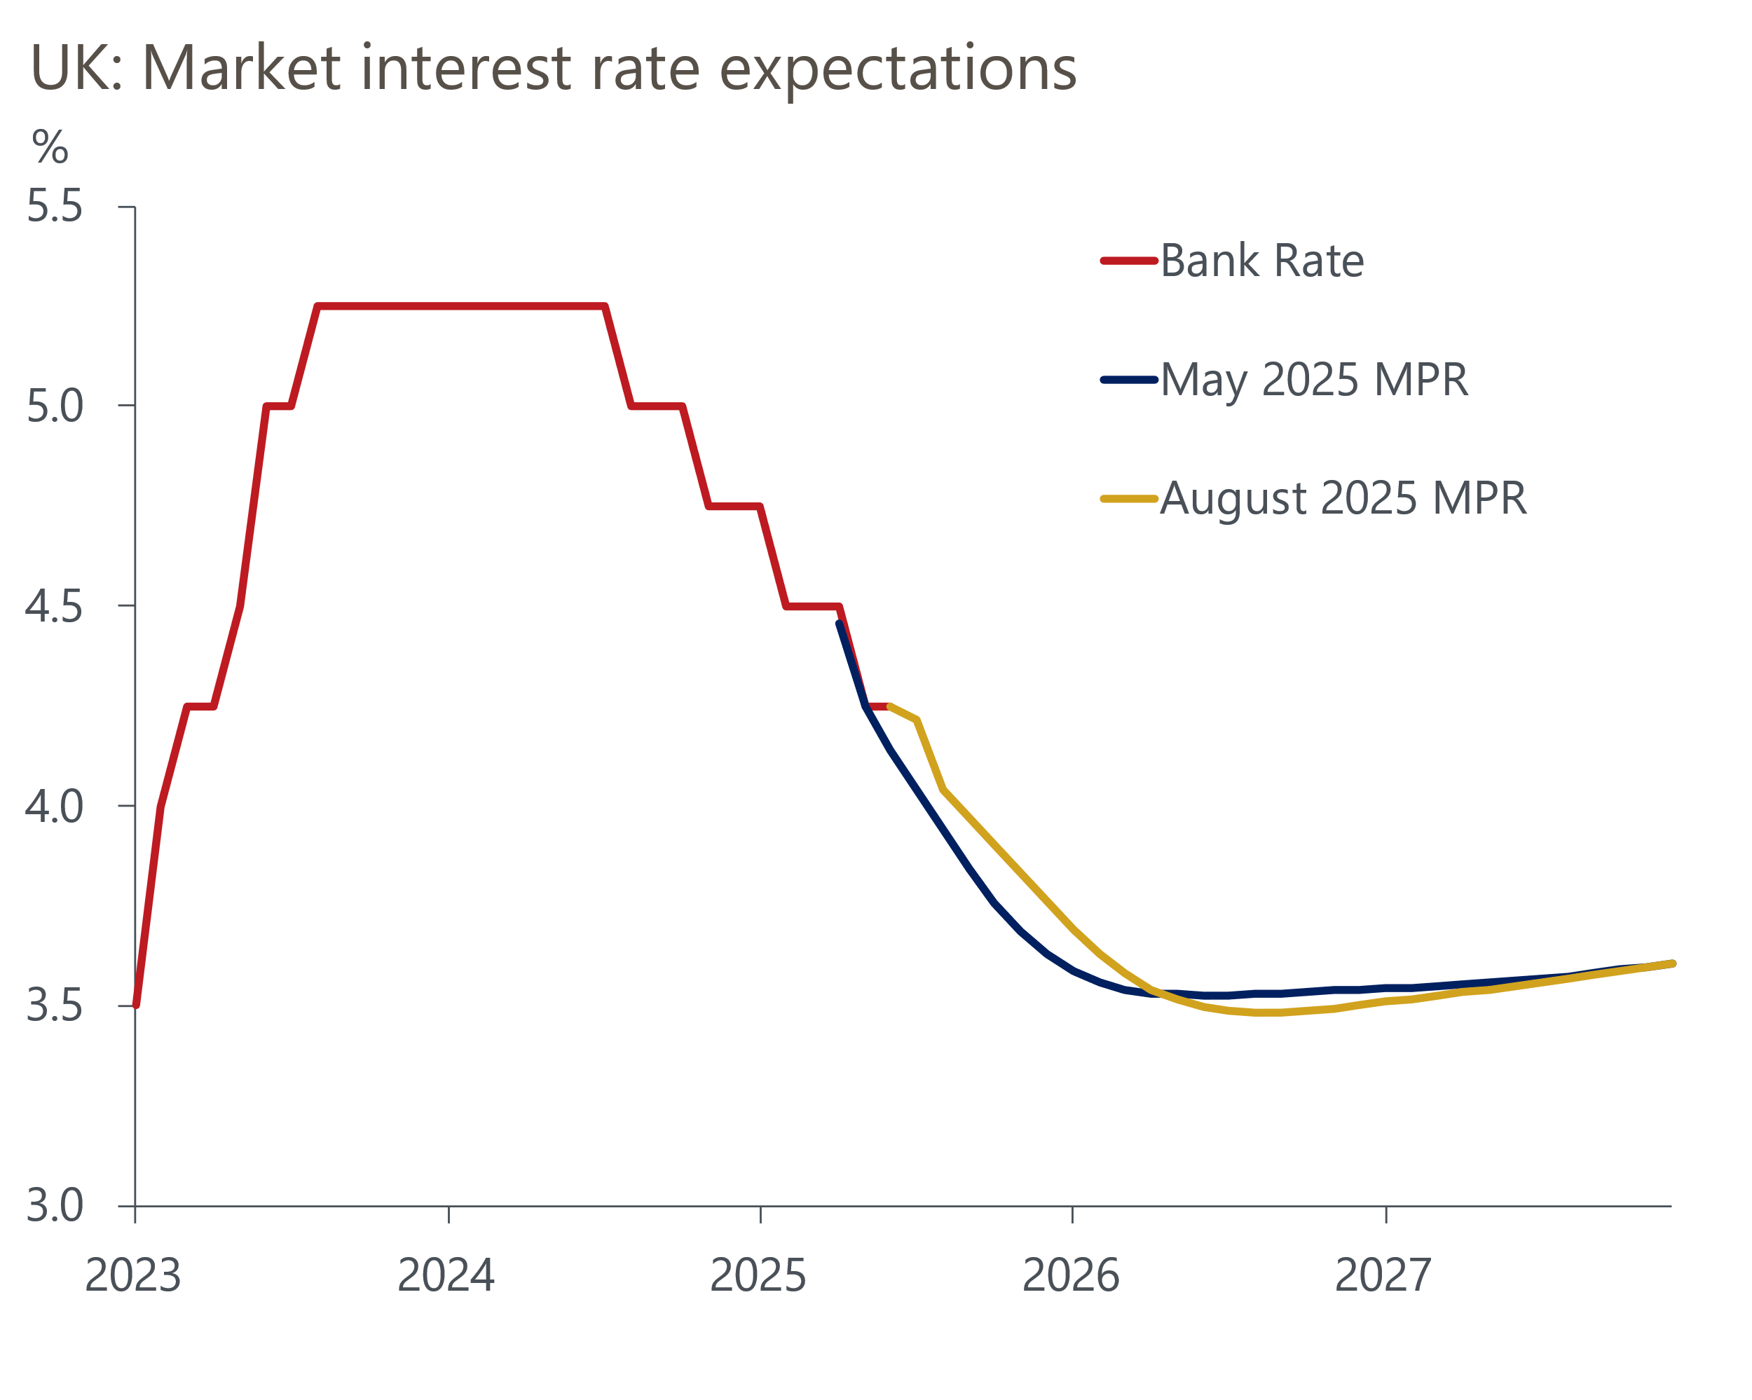
Source: Haver Analytics
In May, the MPC published a forecast where inflation was fractionally below 2% at the two-year horizon. This signalled that policymakers regarded market expectations for a quarterly pace of rate cuts as broadly sensible. With market pricing little changed from May, we think the MPC is likely to reinforce its message that a quarterly pace of rate cuts remains appropriate by keeping its medium-term inflation forecast around the 2% mark once more.
There will be many moving parts to the MPC's forecast, but we expect the changes to be small. With market pricing slightly higher in the near term, this will exert some downward pressure on CPI inflation. But the impact of this is likely to be more than offset by two key factors. First, April's once-a-year price hikes for indexed contracts and regulated prices were relatively large. This will likely bake higher inflation into the BoE's forecast for these services sub-categories for another year. Second, gas, electricity, and oil futures prices have picked up slightly over the past three months (Chart 4). This should raise the BoE's near-term projections for UK petrol and domestic energy prices. Therefore, we expect the MPC's inflation forecast to be slightly higher in the near term and remain at, or be marginally above, 2% at the two-year horizon.
Chart 4: The MPC's new forecasts will assume slightly higher oil and gas prices
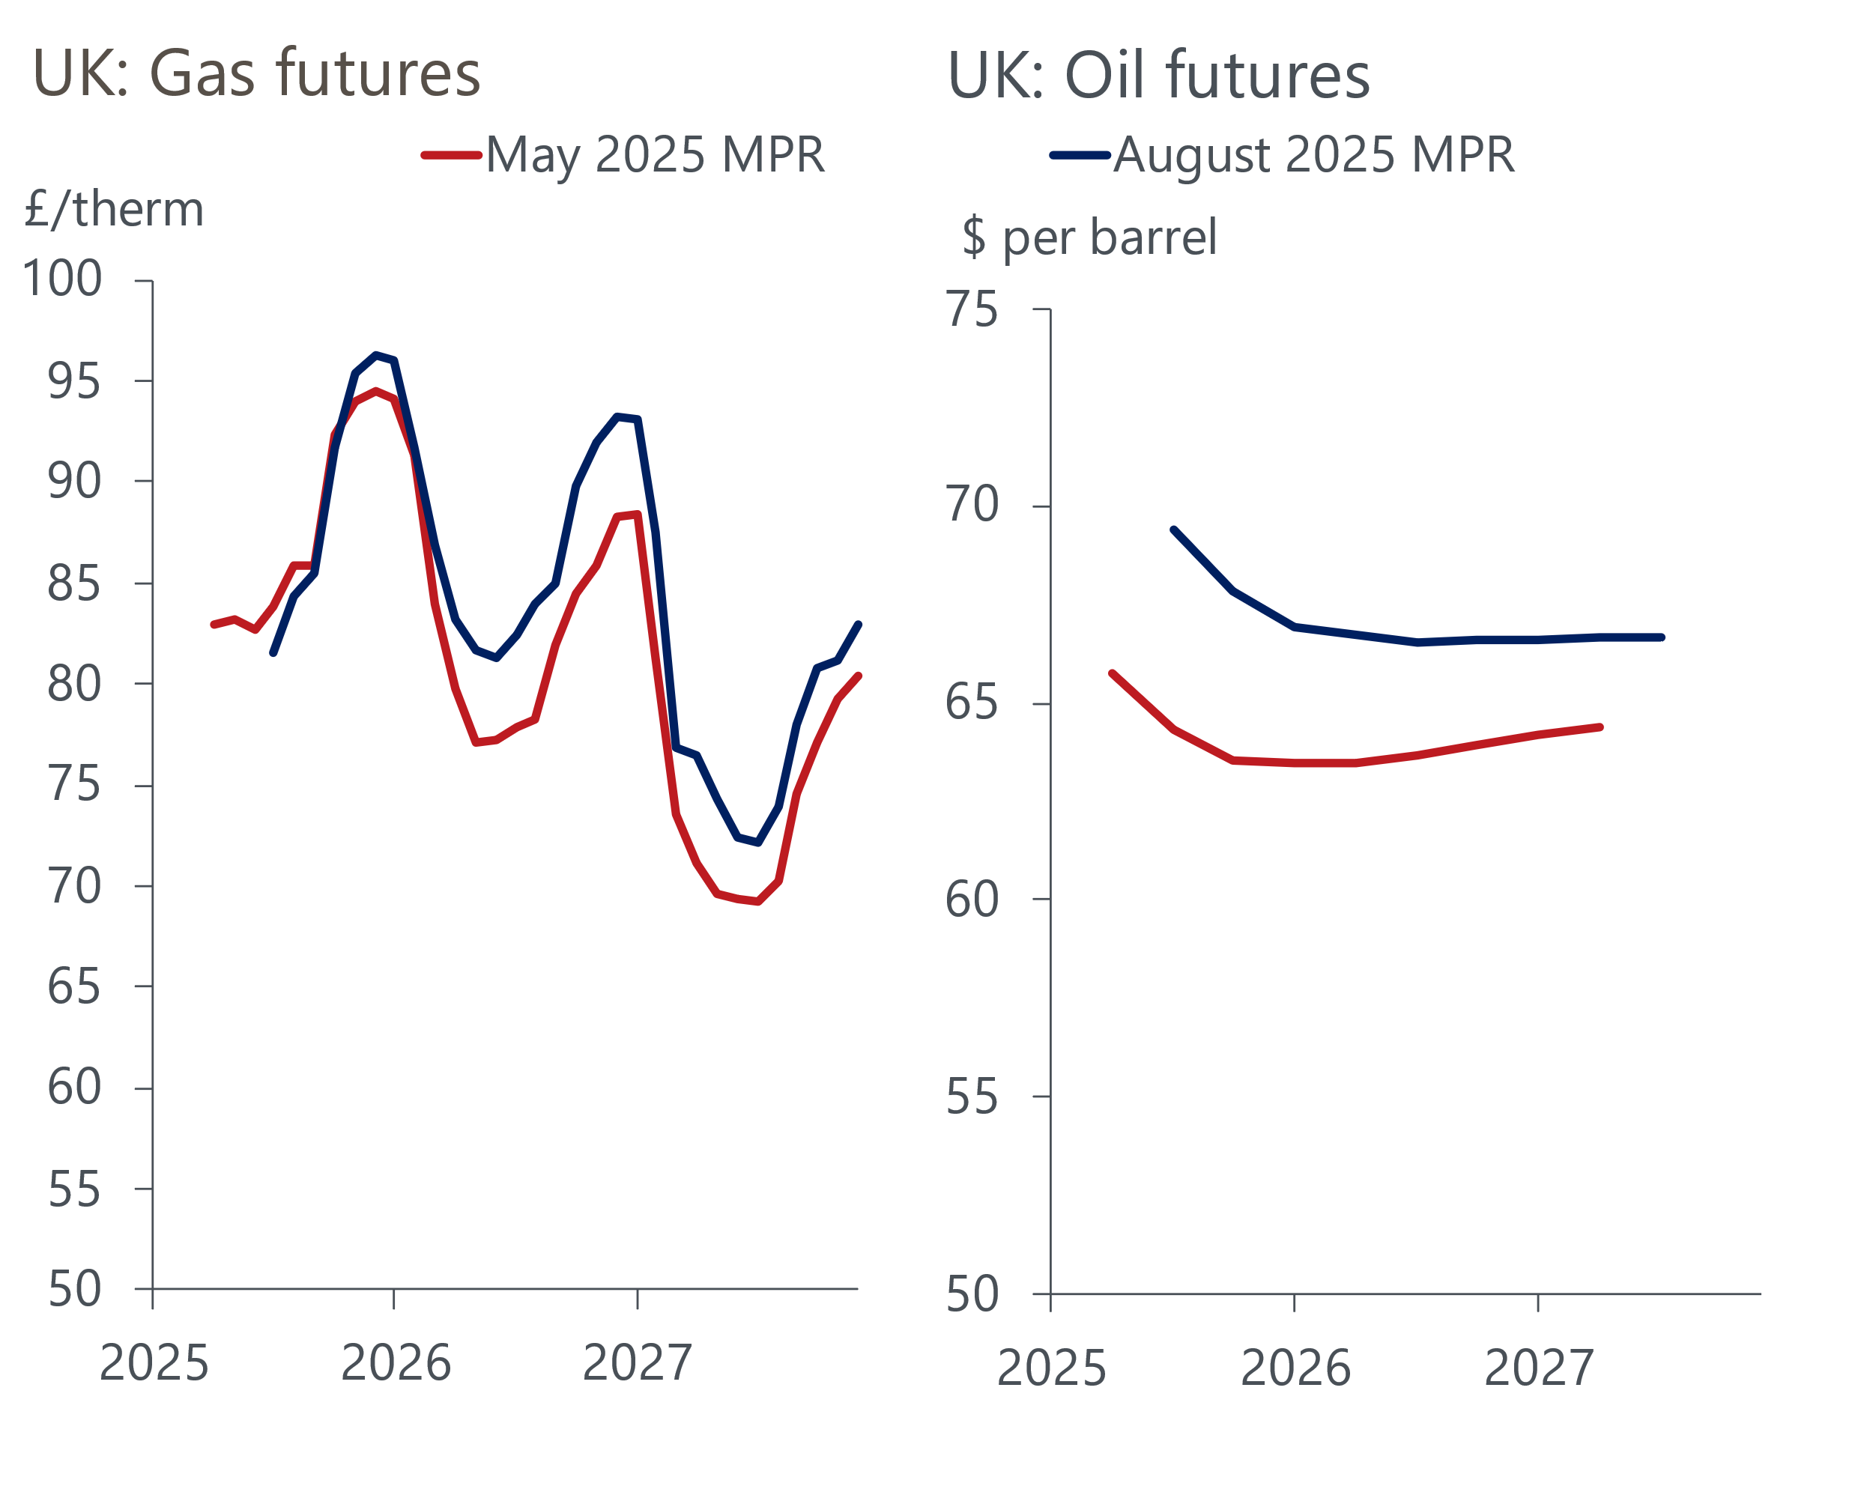
Source: Haver Analytics
A slightly stronger-than-expected performance in Q1 means the MPC's GDP projection will start from a higher level. But higher inflation will erode real wages and, hence, weigh on the near-term growth outlook. The new conditioning path for Bank Rate will have a similar effect. Therefore, we think the MPC will trim its near-term growth forecast, but we anticipate little change to the medium-term growth outlook.
Overall, this would send a clear message that the MPC expects to continue to steadily loosen policy over the rest of this year and that the bar to cutting more quickly is now a bit higher than it was after the June meeting. Our baseline forecast assumes that the cut-hold tempo is maintained throughout H2 2025, with 25bp cuts in August and November, and Bank Rate falling further in 2026.

The MPC may use its report to signal that it will vote to slow the pace of QT in September
At the September meeting, the MPC will vote on the pace of quantitative tightening over the coming year. As was the case in the August 2024 Monetary Policy Report, the BoE may include a box in next week's Monetary Policy Report laying out the evidence of the impact of QT on gilt yields and the real economy ahead of September's vote. The MPC has previously made it clear that it sees no conflict between cutting rates and continuing with QT, but we expect the committee to lower next year's QT target to £75bn-£80bn, from the current pace of £100bn per year, in response to the sharp rise and higher volatility in gilt yields.

